Bug_01:
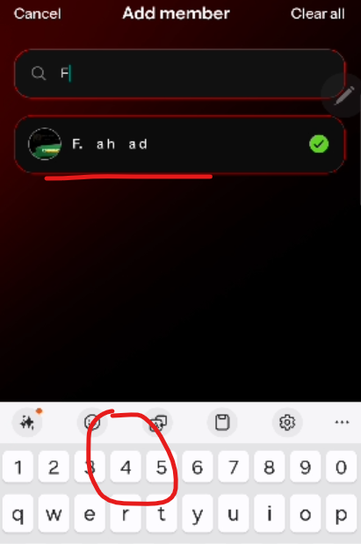
After selecting the member, the keypad should be close.
Bug_02:
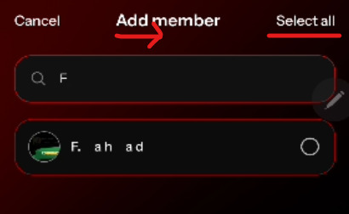
After clicking on select all, the Add Member text place towards right
Bug_03:
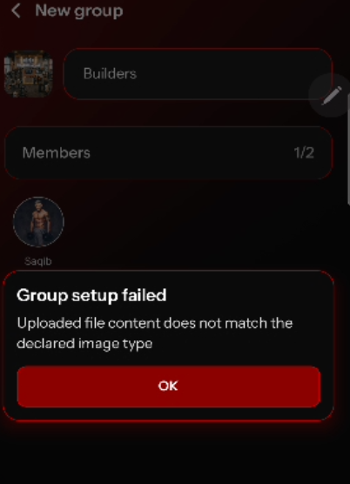
File Upload error when uploaded the correct picture

Bug_04:


Bug_05:

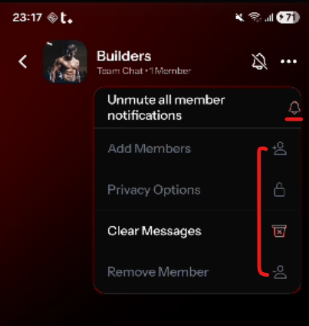
Inconsistency
Bug_06:
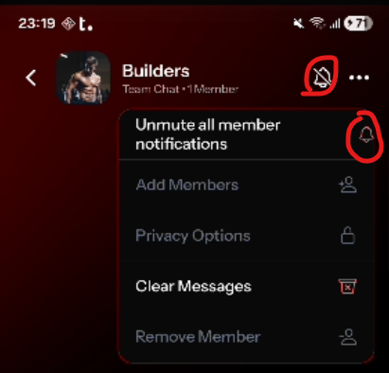
These 2 bell icon buttons are not sync
Bug_07:
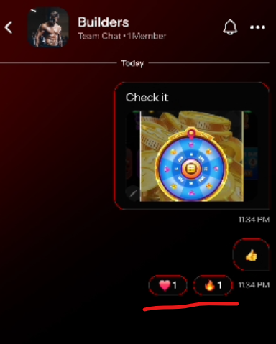
Both heart and fire reactions are mine

Bug_08:
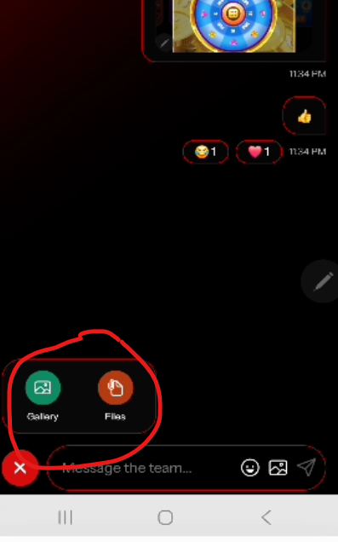
File options should b close when user click anywhere on screen

Bug_09:
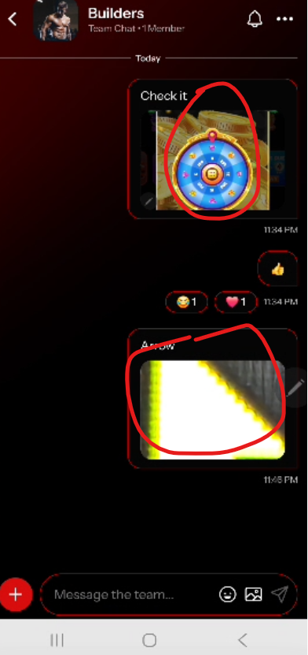
These pic’s should be expandable (preview) when user click on it.

Bug_10:
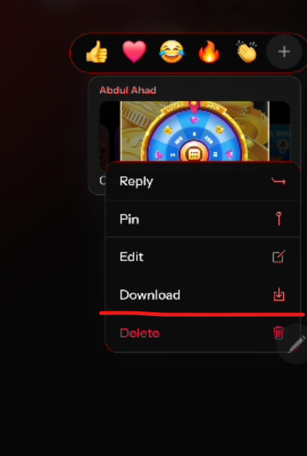
Too much response time of download button and not downloading the image
Bug_11:
Before deleting any message, the confirmation message should be appear, like “ This message will be deleted from you/everyone”
Bug_12:
When Coach add any member in group, the message should be display “you added fahad”.
Bug_13:
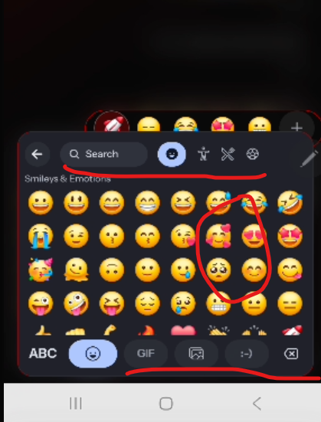
Not scrolling on right side and other options are not working like gif, photo etc.
Bug_14:
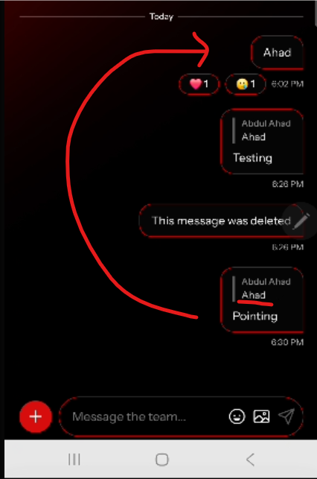
When click on “Pointing” text message, it should redirect/point to the “Ahad” text message
Bug_15:
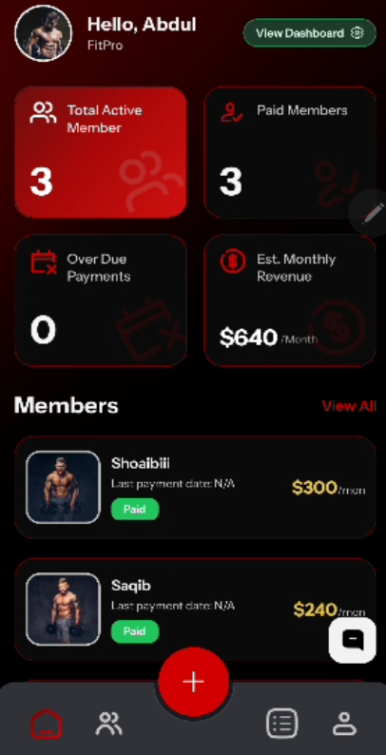
When any member send message in group from student app, admin click on notification to open the group but it redirects to dashboard instead of group chat.
Bug_16:
